Name: Yashraj Suresh Patil

Prn: 2020BTECS00069

TY CSE

**ASSIGNMENT 9**

**Q 1. What are the prerequisites for installing the Selenium.**

🡺Before installing Selenium, you will need to make sure that your system meets the following prerequisites:

1. Programming language: Selenium supports a variety of programming languages such as Java, Python, Ruby, C#, and JavaScript. You should have basic knowledge of at least one of these programming languages.
2. Web Browser: Selenium works with a variety of web browsers such as Google Chrome, Mozilla Firefox, Microsoft Edge, and Safari. You will need to have one or more of these web browsers installed on your system.
3. Webdriver: Webdriver is a component of Selenium that allows it to interact with the web browser. You will need to download the appropriate webdriver for the web browser you plan to use. For example, if you plan to use Chrome, you will need to download the Chrome webdriver.
4. Integrated Development Environment (IDE): An IDE is a software application that provides a comprehensive environment for developing code. Although not strictly necessary, an IDE such as Eclipse, PyCharm, or Visual Studio Code can make the development process easier and more efficient.
5. Selenium Library: You will need to install the Selenium library for your chosen programming language. This can usually be done using a package manager such as pip for Python or Maven for Java.

Once you have met these prerequisites, you should be ready to install and use Selenium.

**Q 2. Install Selenium tool on your machine (Provide screen shots for successful installation and login)**

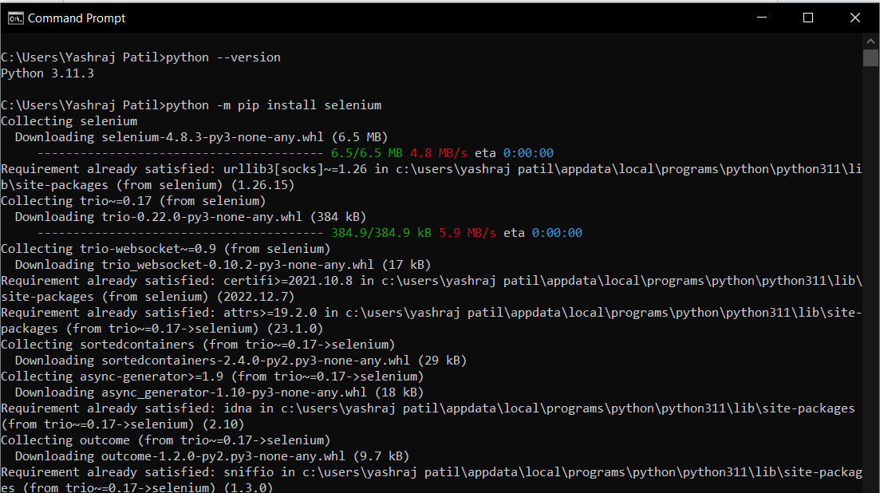

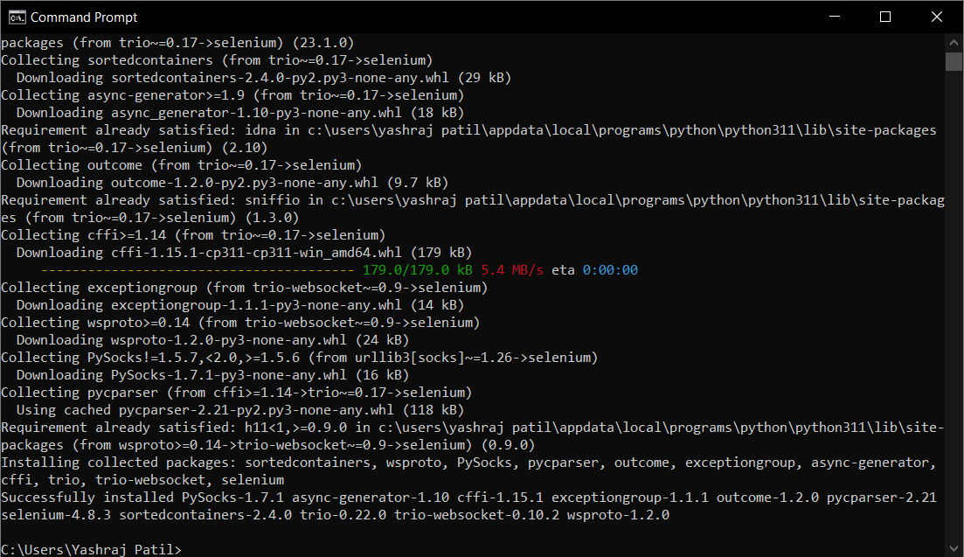

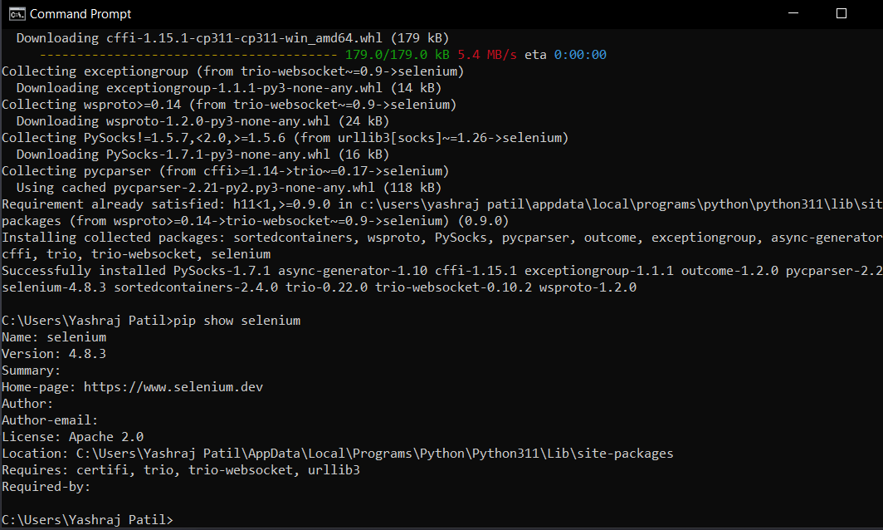

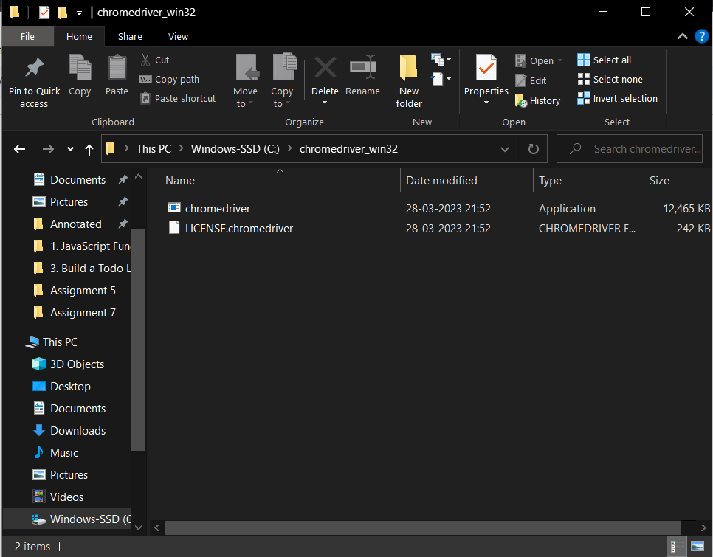

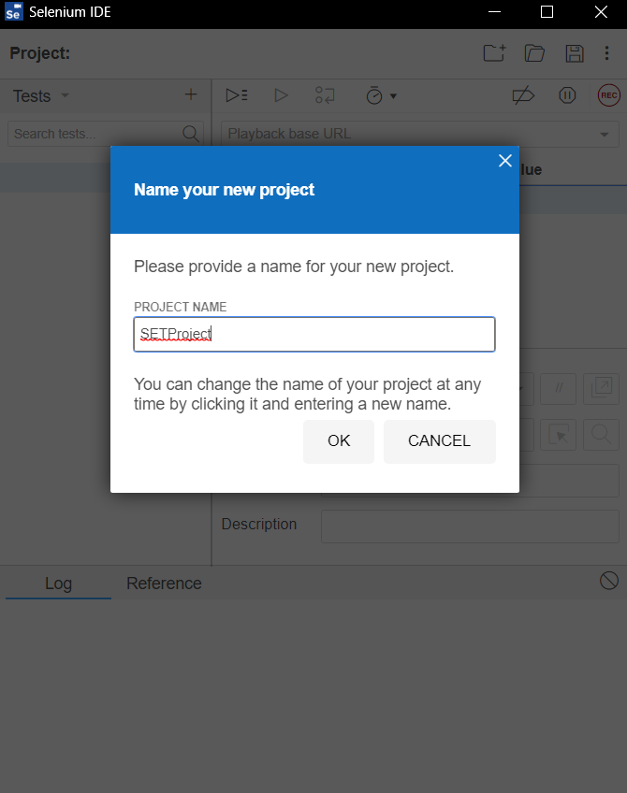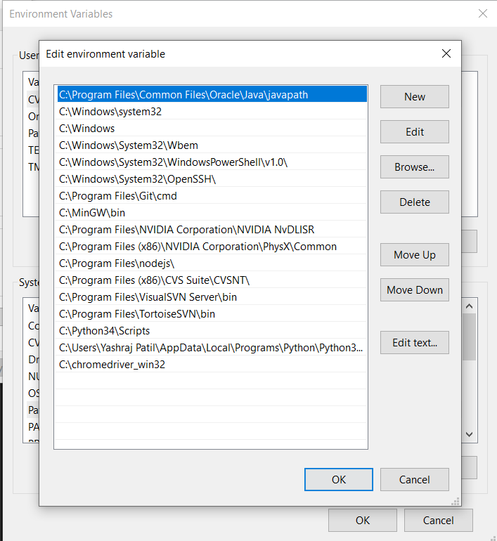

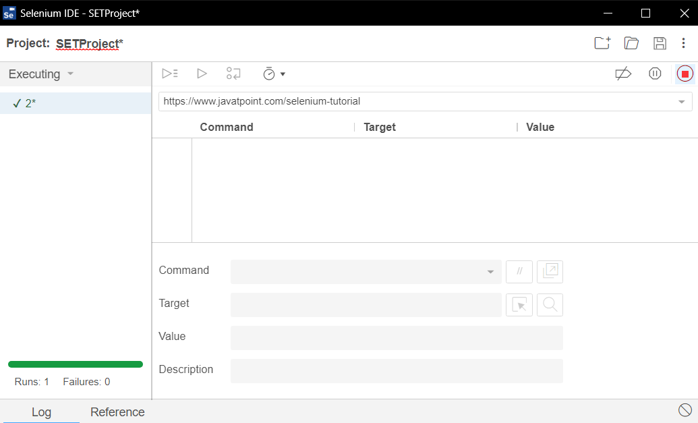

**Q 3. Using Selenium tool create multiple test cases (at least 10) on any application/project that you have implemented.**

* **1. Run test case**

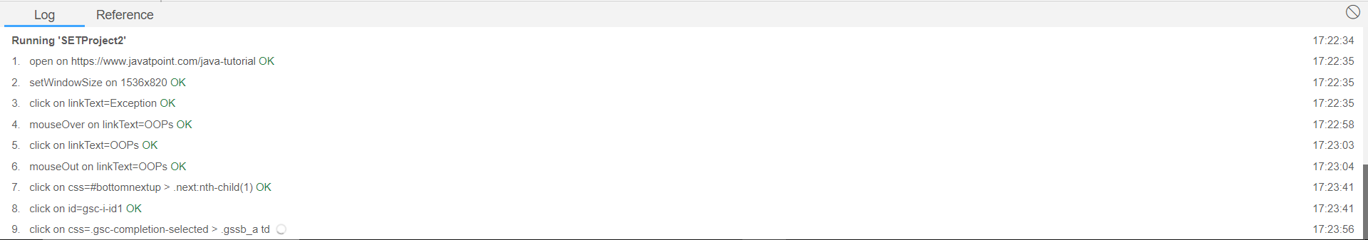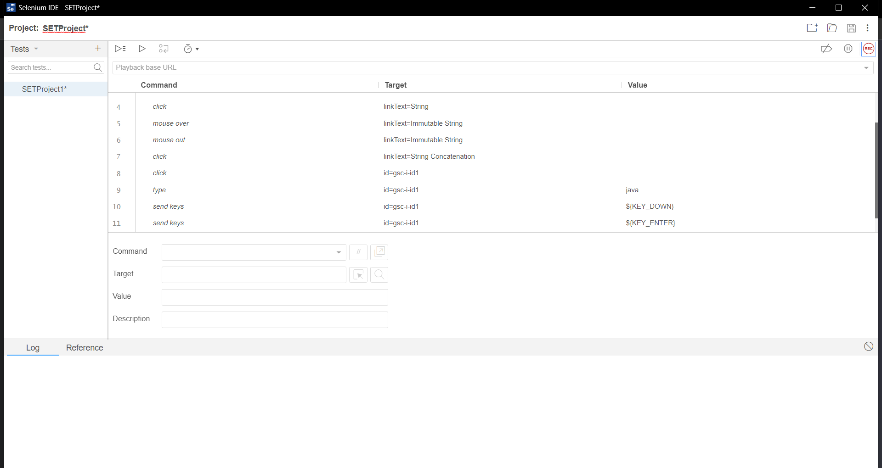

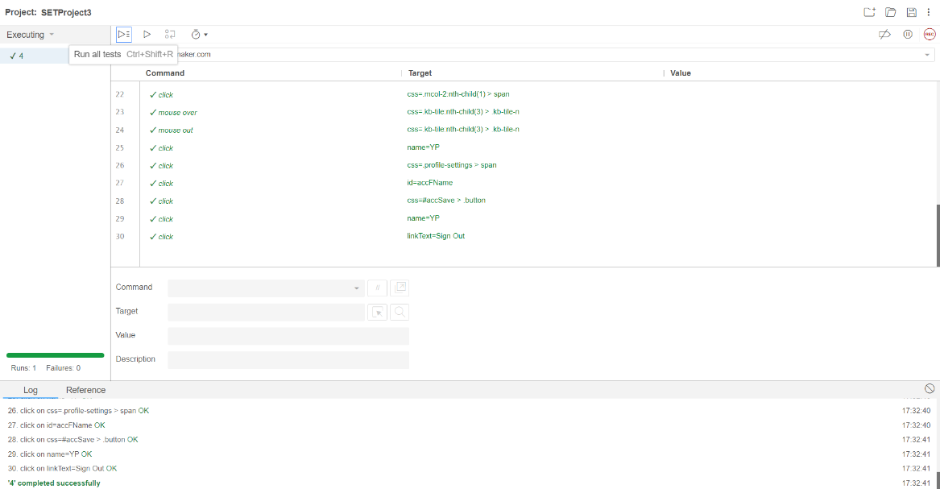**2.** **Login Test Case**

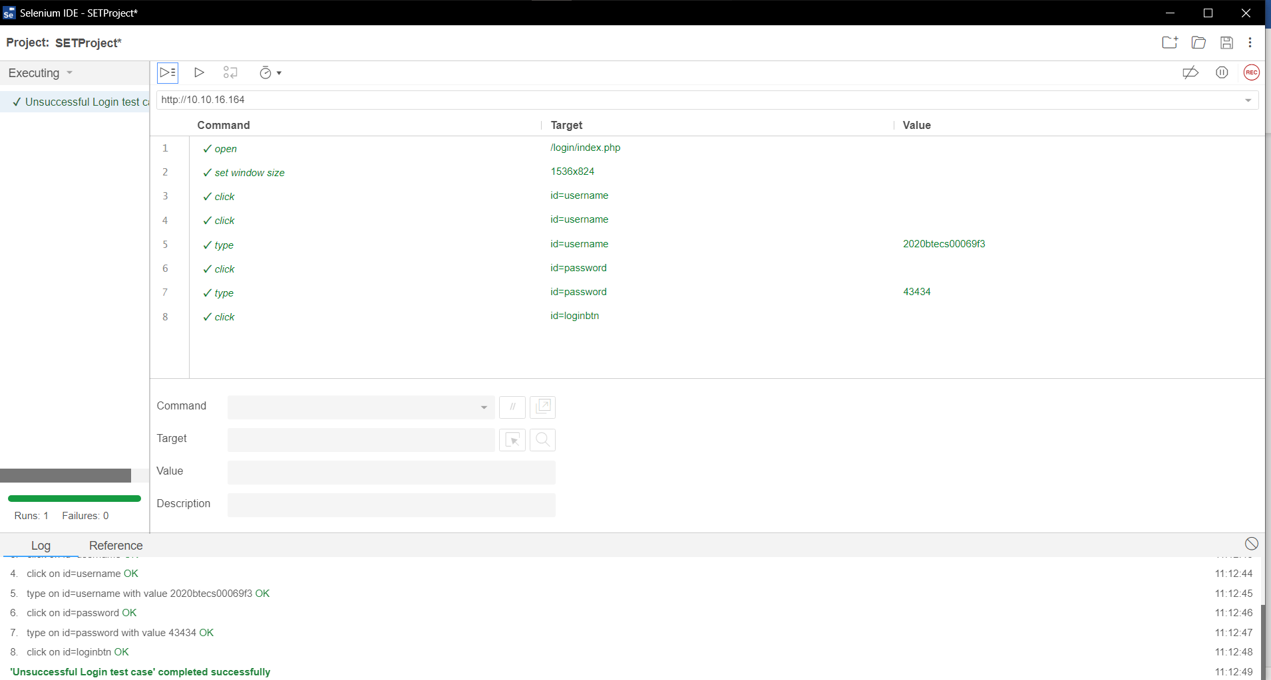**3. Unsuccessful login Test Case**

**4. Empty username and password test case**

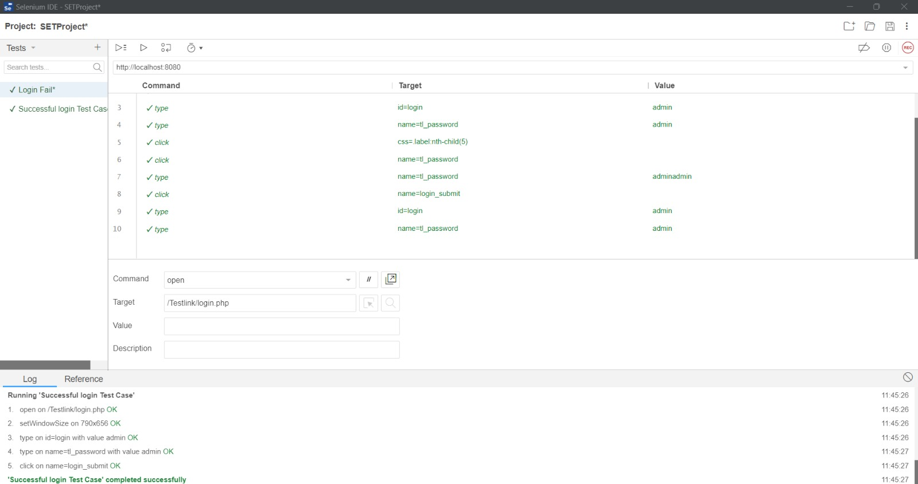

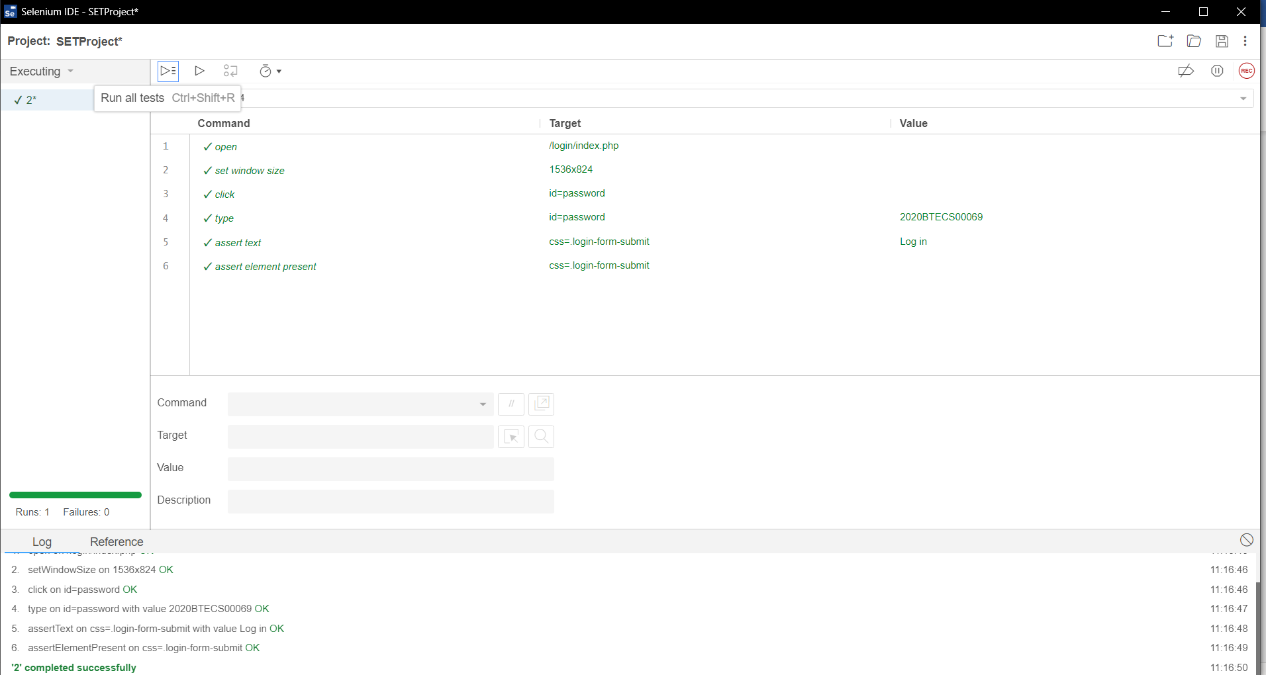**5. Verify password is hidden (masked) while typing**

**6. Verify that the site throws an error if you try to submit file of that exceeds maximum size limit.**

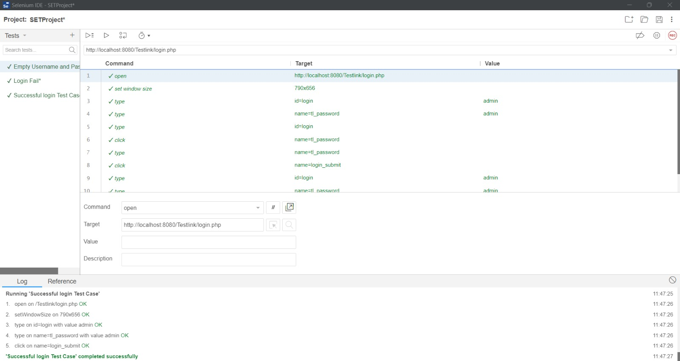**7. Verify that the site allows multiple file types to be uploaded, such as .docx, .pdf, or .txt.**

**8. Verify that the site prevents a user from submitting an assignment if they have already submitted it before.**



**9. Verify that a user can view their submitted assignments and any feedback or grades provided by the instructor.**

**10. Verify that the site displays the correct assignment details, such as the due date and submission instructions.**